

Mawlana Bhashani Science and Technology University

Lab-Report

Report No:02
Course code: ICT-3110
Course title: Operating System Lab
Date of Performance:01/09/2020
Date of Submission:10/09/2020

Submitted by Submitted To

Name:Md Milon Ahmed
ID:IT-18034
3rd year 1st semester
Session: 2017-2018
Dept. of ICT
MBSTU.

Nazrul Islam
Assistant Professor
Dept. of ICT
MBSTU.

Experiment No:01
Experiment Name: How To Set Up Linux Ubuntu.(17.10)
Aim and Object:
There are different types of Operating system. Some examples include versions of Microsoft Windows (like Windows 10, Windows 8, Windows 7, Windows Vista, and Windows XP), Apple's macOS (formerly OS X), iOS, Chrome OS, BlackBerry Tablet OS, and flavors of the open source operating system Linux. Different type of Linux distribution and version is exist.
We use linux operating system because:
- Linux is Free an Open Source.
- Linux can run low Hardware machines too.
- Well supported.
- Lots of Flavors.
- Good security.
Experiment Setup: Here we will implement Linux Ubuntu 17.10 . We will do Dual-Boot Linux ubuntu 17.10 and Windows 10.
The install process is given below.
5 steps to Dual-Booting:
- Download the Linux Mint operating system (in an iso file format) from Linux ubuntu website.
- Downloads Rufus (a program for creating boot-able USB flash drives).
- Use Rufus to create a boot-able USB flash drive and copy Linux Mint onto it.
- Restart your pc and load Linux Ubuntu from your USB flash drive.
- Run the Mint installation wizard to install Linux Mint 18.2 along-side Windows 10 (64 bit).
Step 1:
Download Linux Ubuntu:
we will Download Linux ubuntu operating System in an iso file format from linux ubuntu website. http://linuxubuntu.com/
Before Downloading linux mint we will download Deluge. Deluge is an open source bittorent application. We will dowload it so that during downloading Linux mint no error is occured.

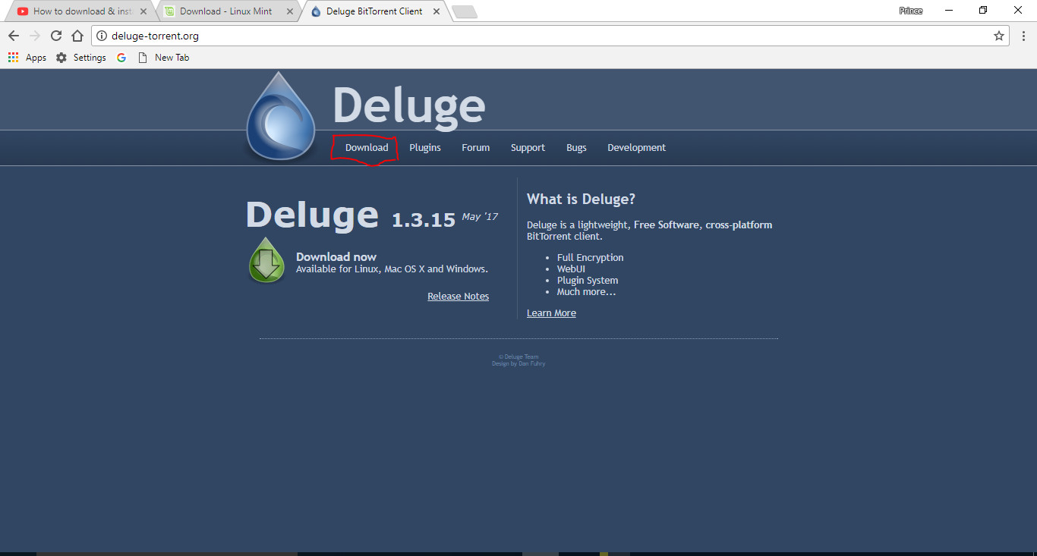
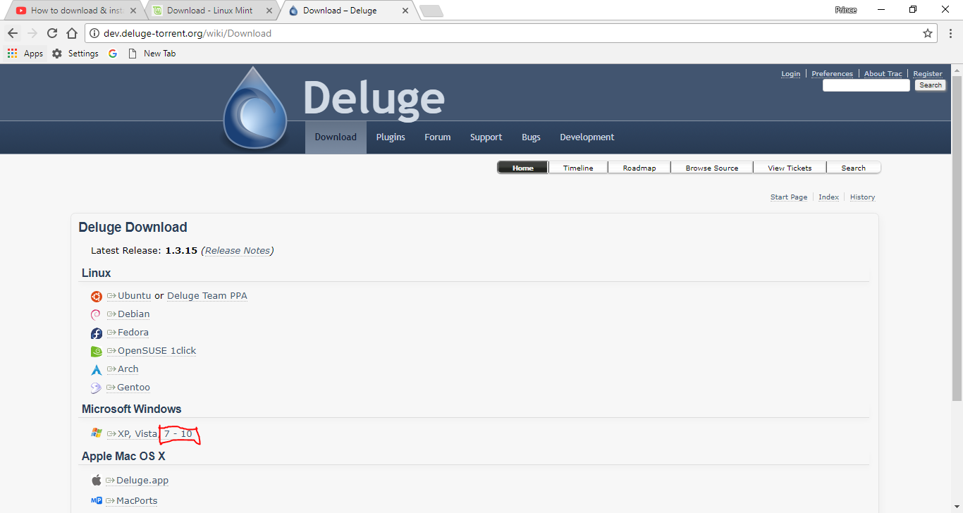
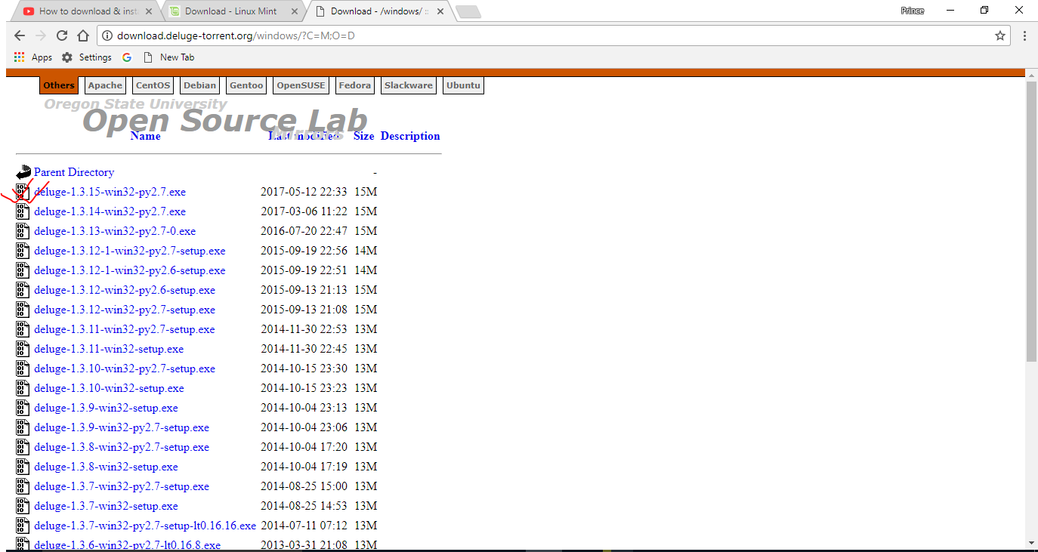
Download and the try for running.
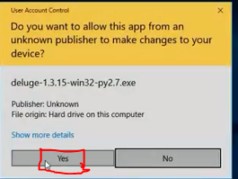
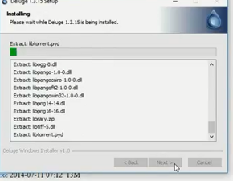
After installing Deluge we will do...
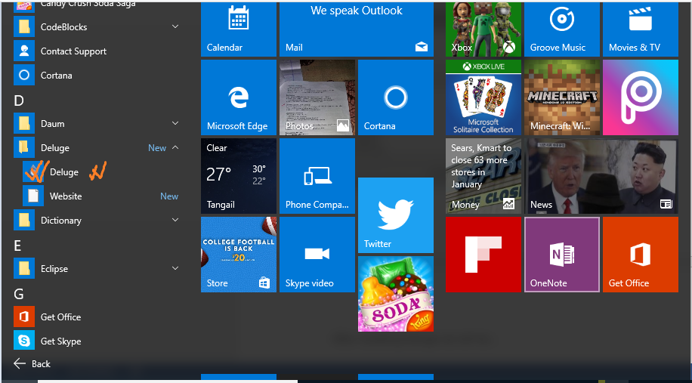
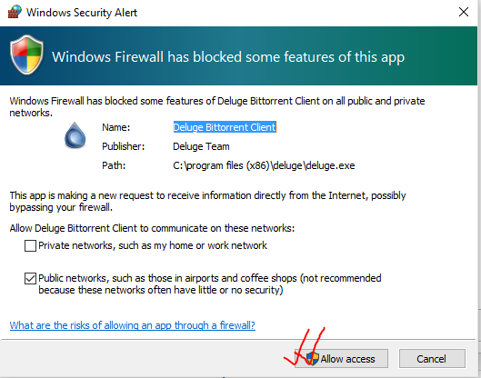
Then we download linux mint
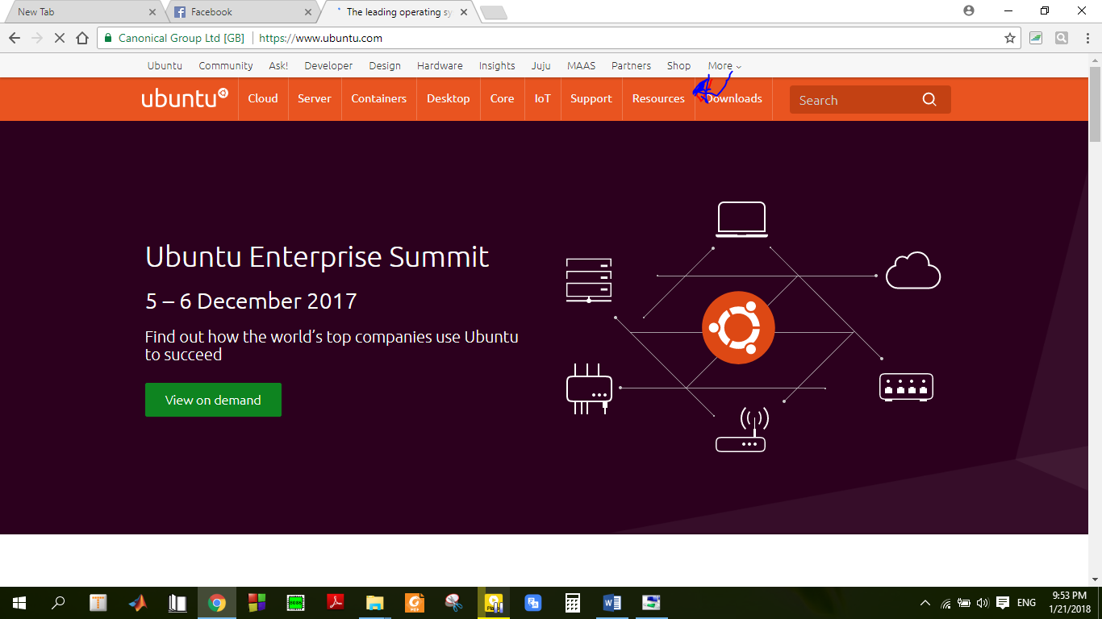

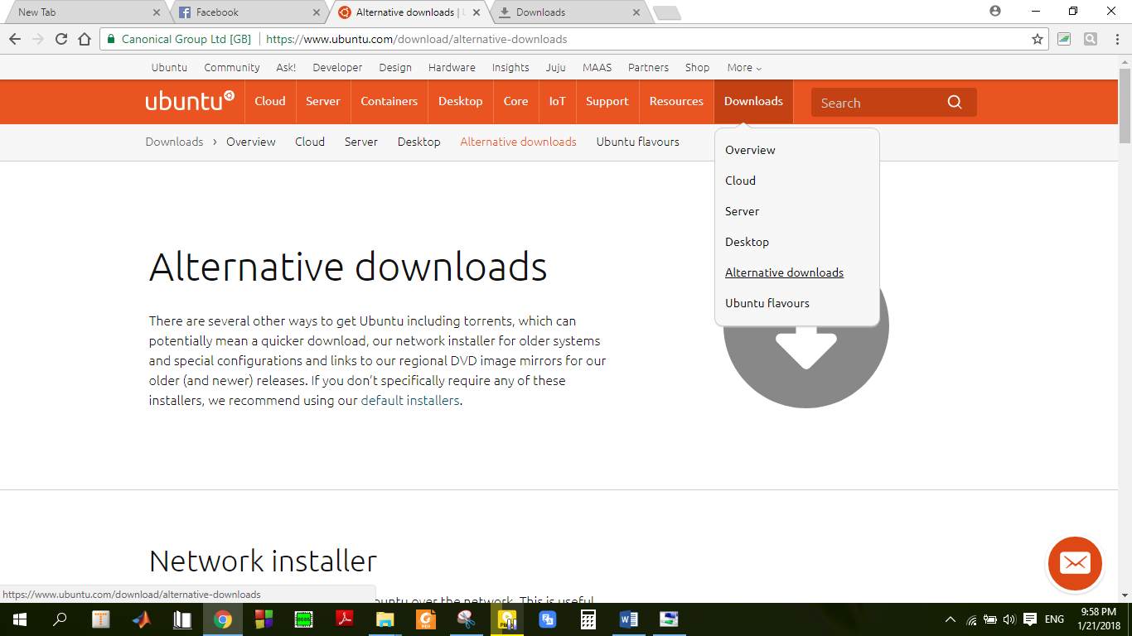
Then we will open it through deluge
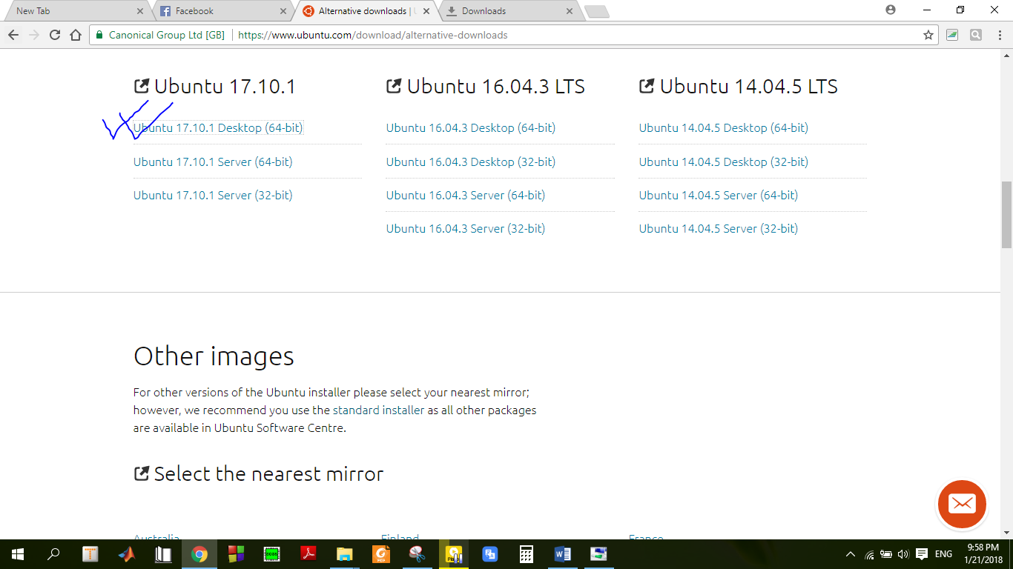
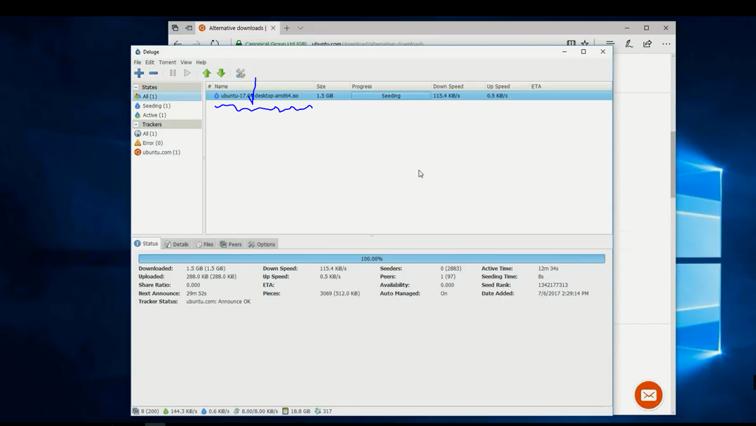

STEP 02 && 03:
We will install Rufus.
Befor installing Rufus connect a USB flash drive with pc.

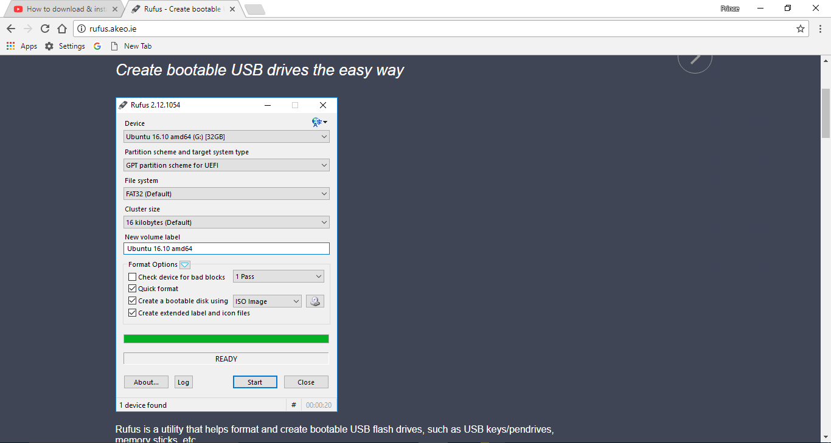
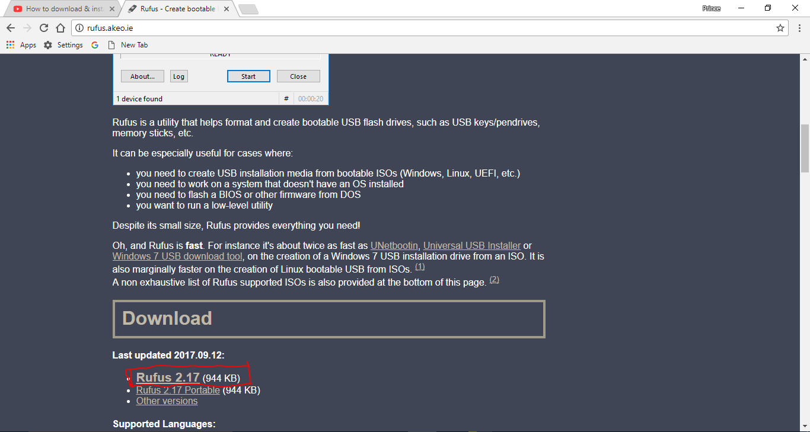
After Download the Rufus then we Run it. Then

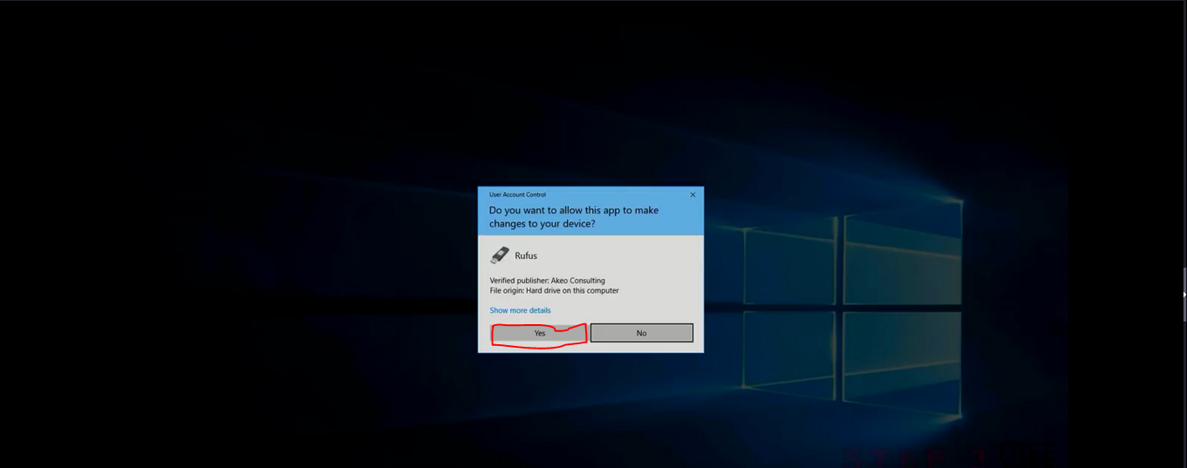
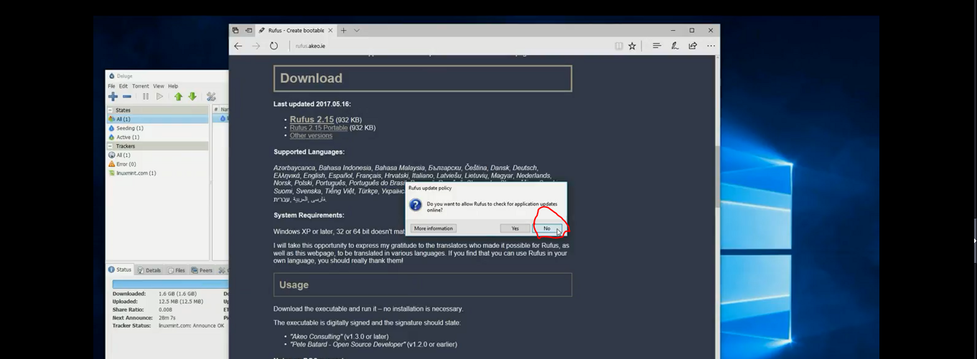
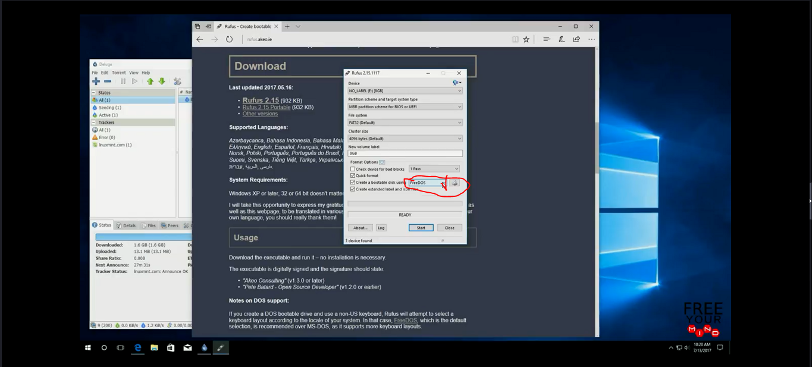
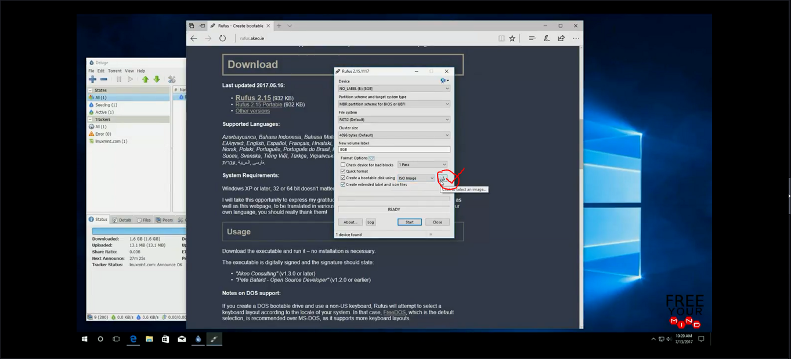
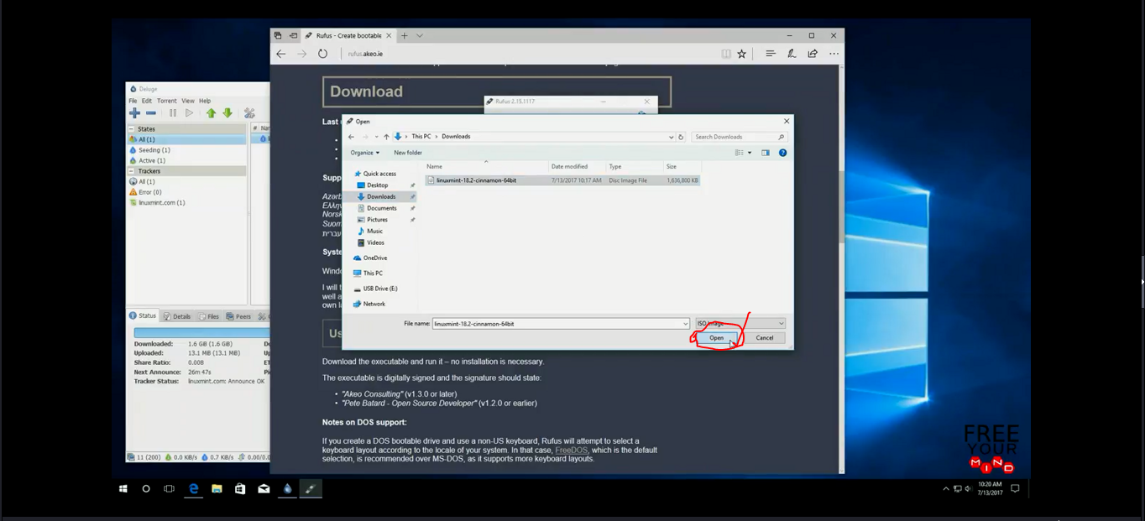
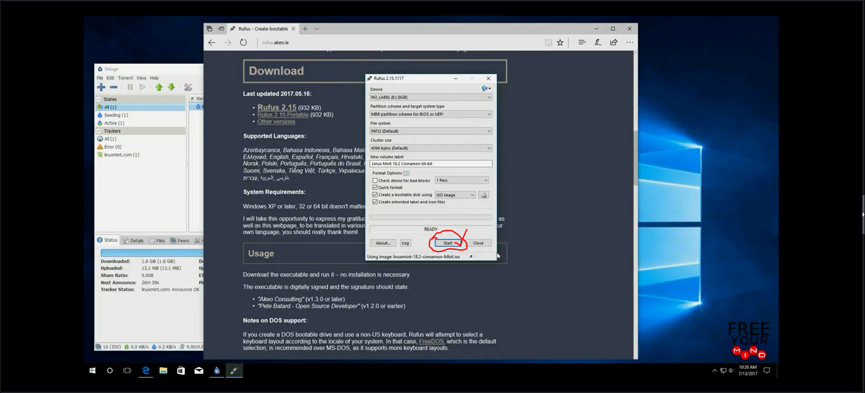
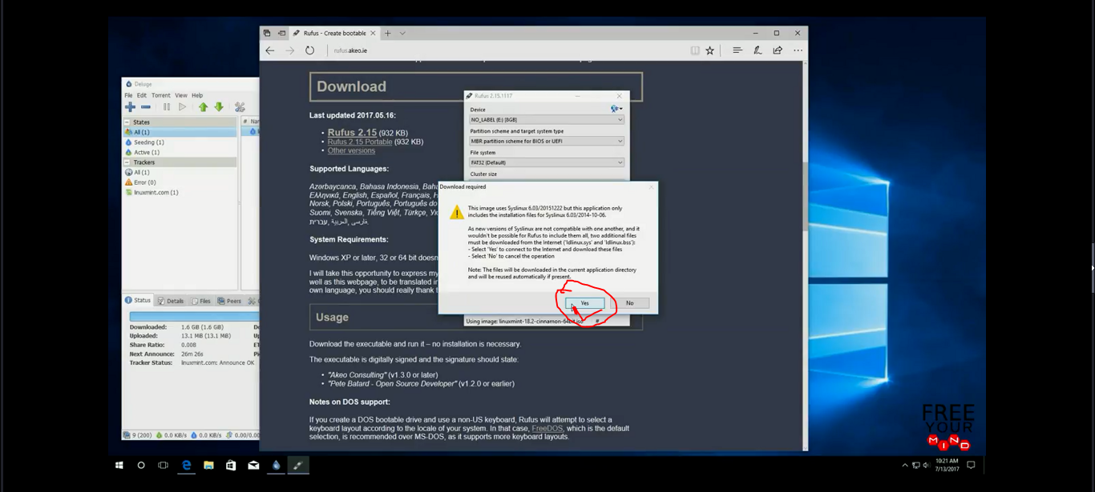
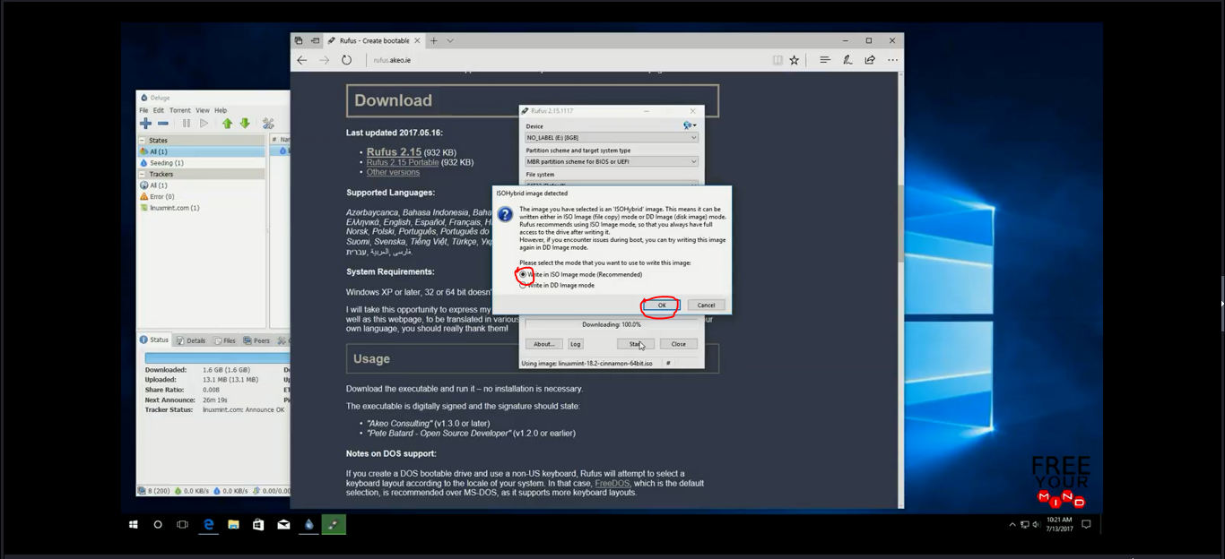
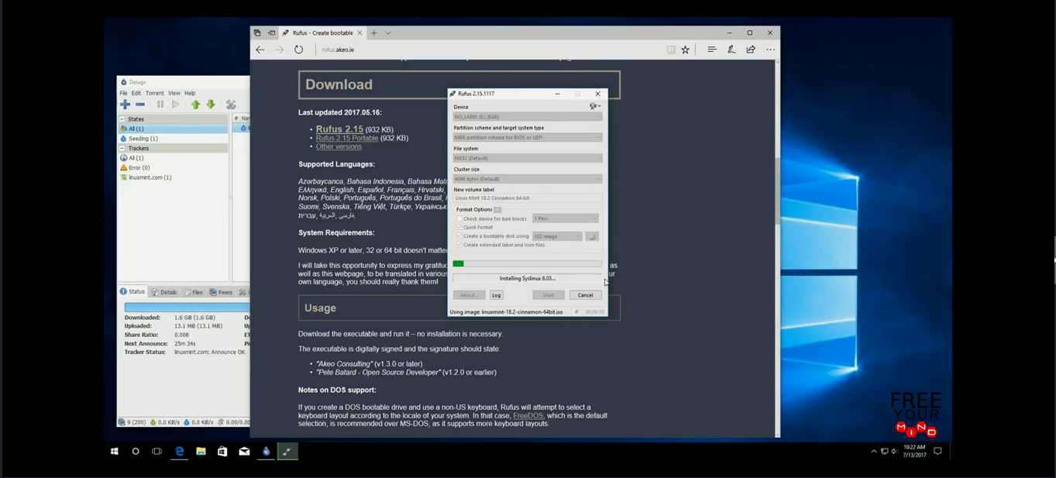

Step 2 and 3 has finished.
Now we can Restart the pc.

Step 04:
Boot Linux-Mint From USB .

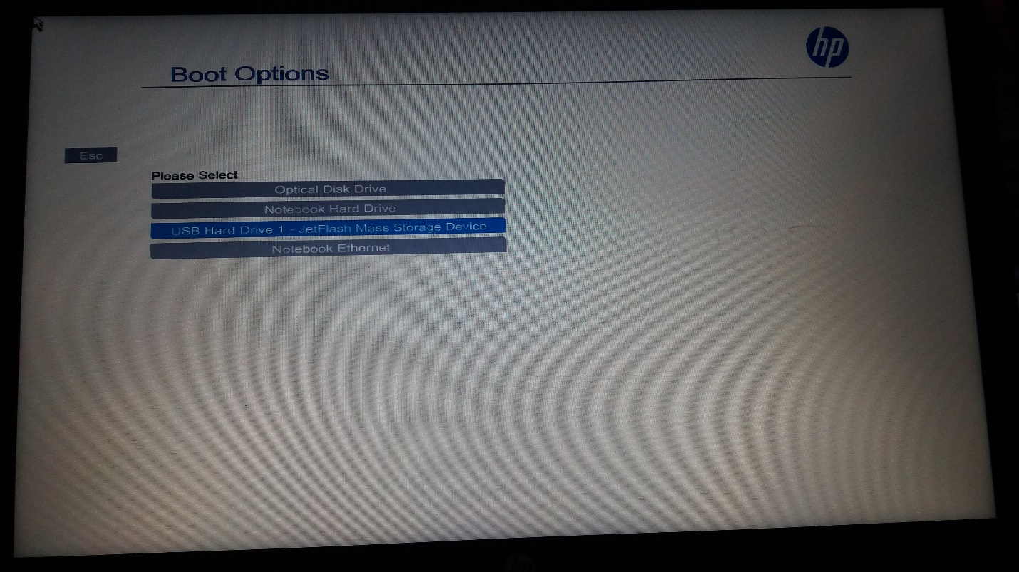

Now press enter button.

Step 05: Install Linux-ubuntu

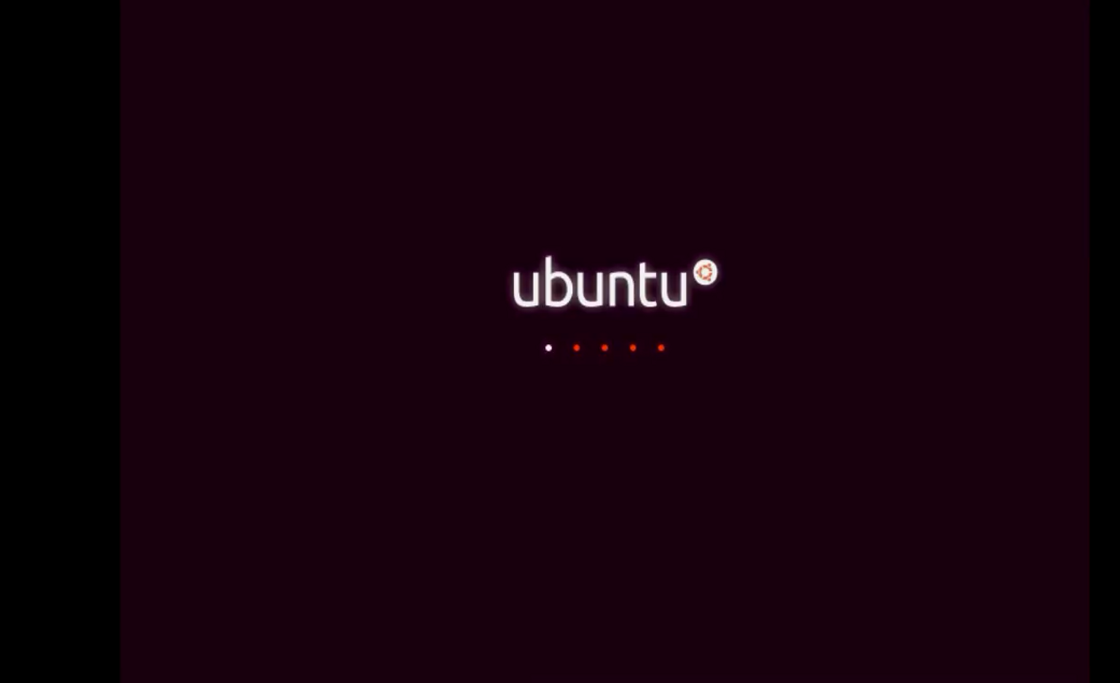

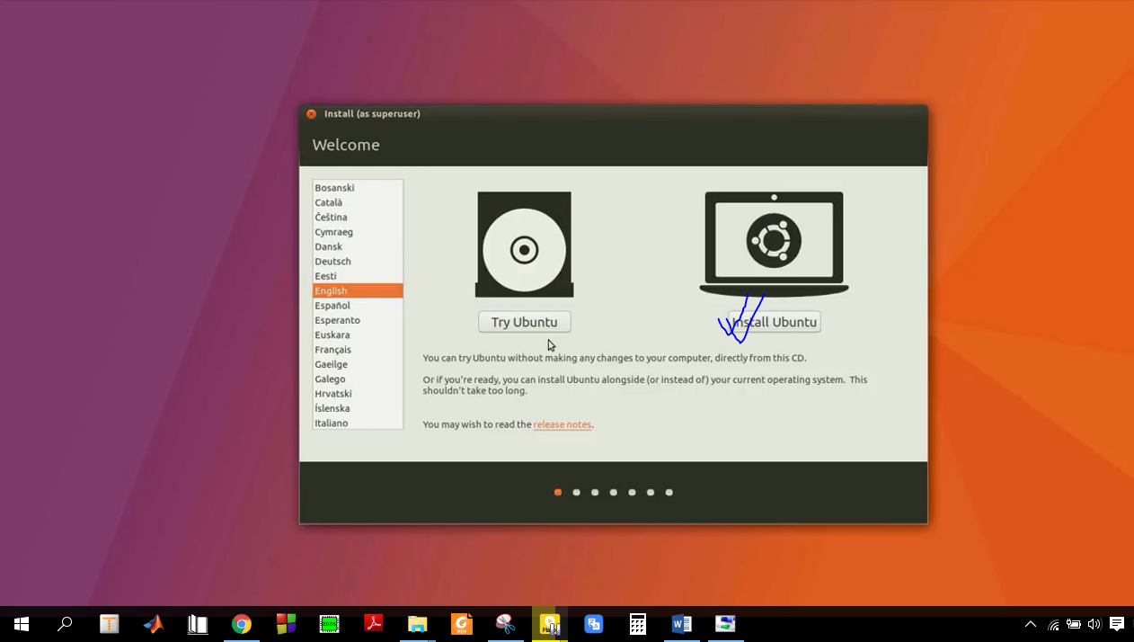
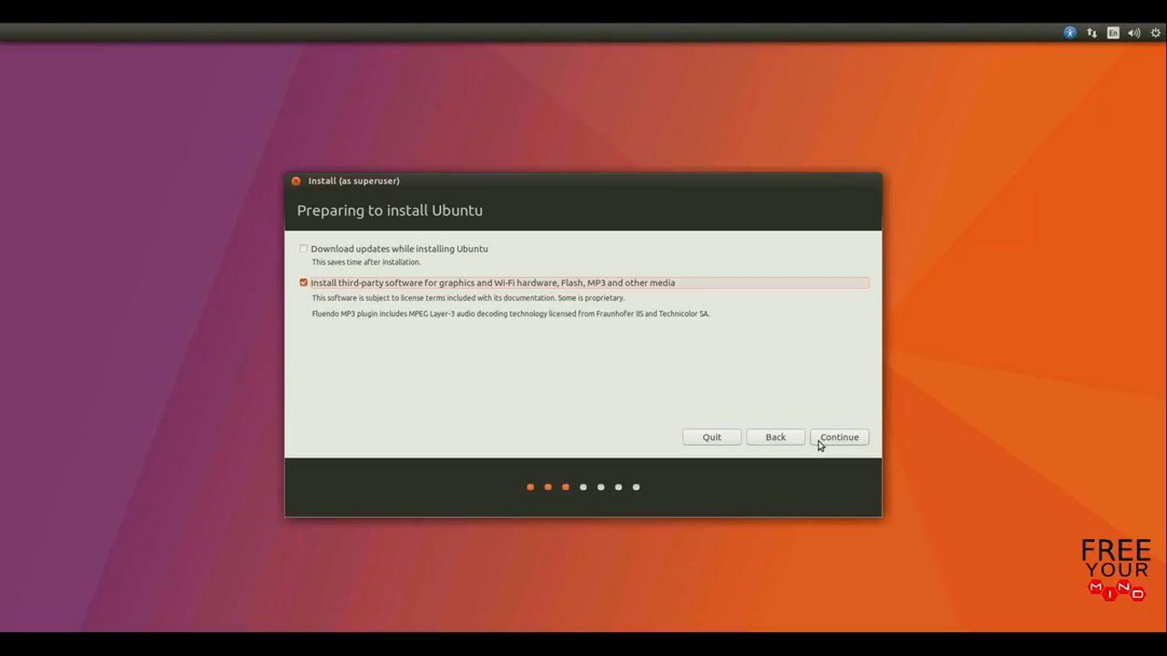
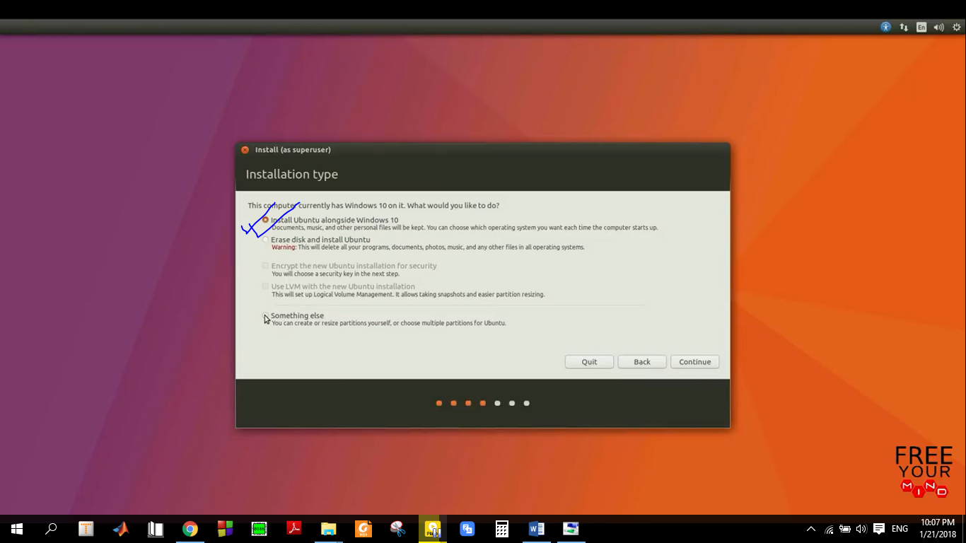
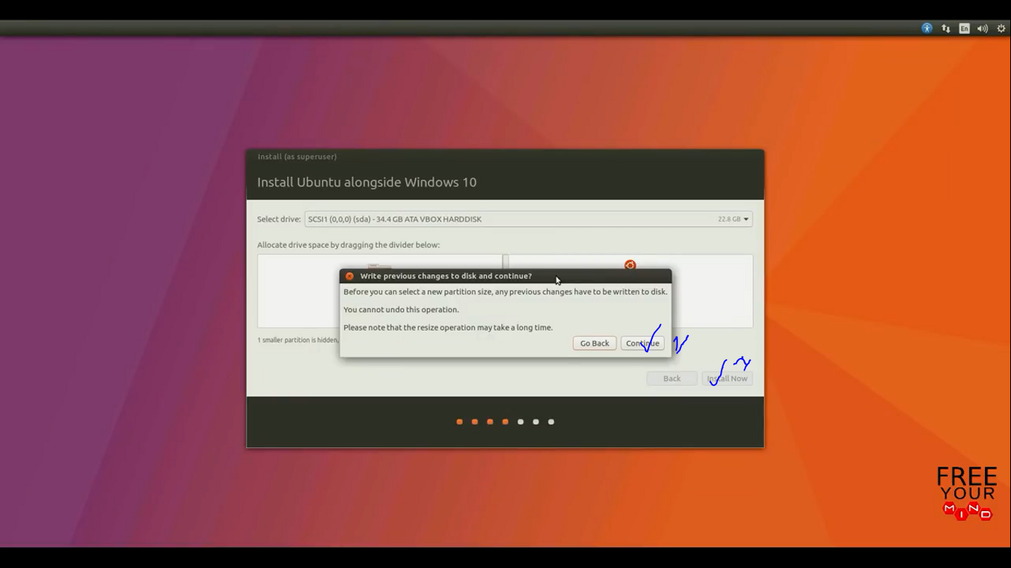

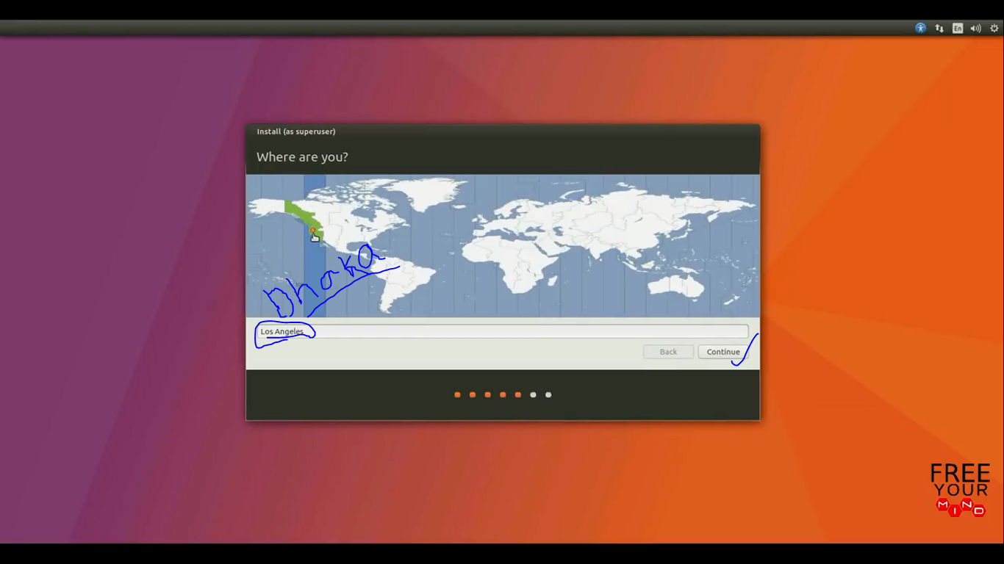

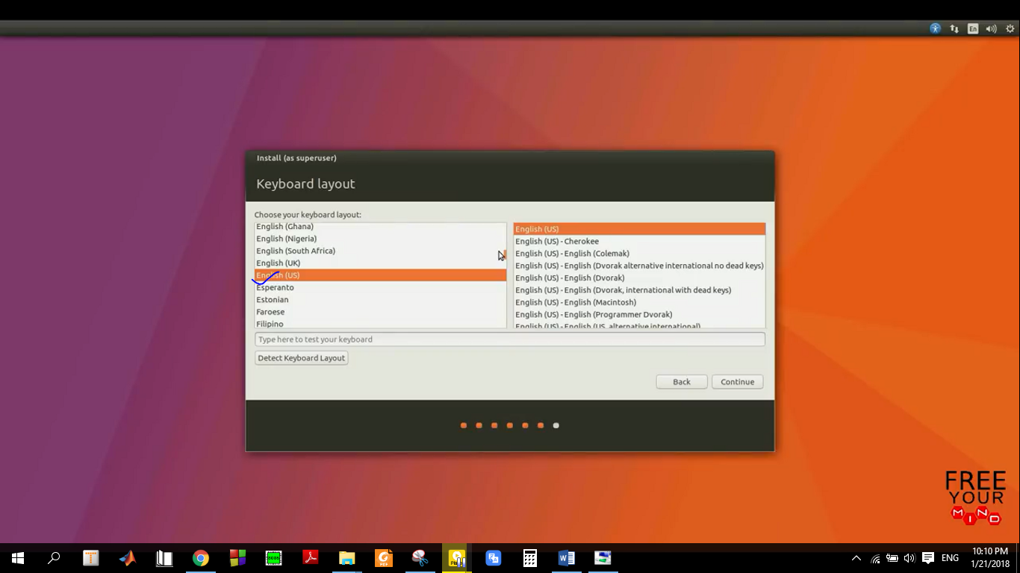
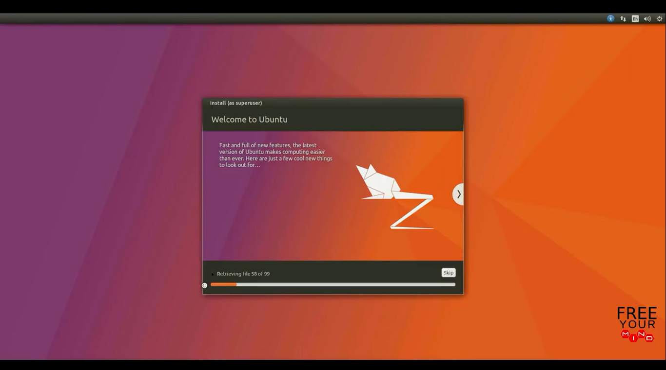

Conclusion: Finally i install the linux from the help of online video and different blog . Actually it is Linux-mint 18.2 ‘Sonya’ cinnamon.

